Press Release
IEA SHC Announces Top Five Nominees for the 2026 SHC Solar Award
Five outstanding projects recognized for advancing solar heating and cooling innovation, market development, and decarbonization
July 2026 — The IEA Solar Heating and Cooling Technology Collaboration Programme (IEA SHC) is pleased to announce the five shortlisted nominees for the 2026 SHC Solar Award. Selected by an international panel of judges from the IEA SHC Solar Award Committee, the shortlisted projects represent a diverse and highly innovative group of solar heating and cooling solutions with measurable impact, strong market potential, and clear contributions to reducing the cost and environmental impact of heating and cooling.
The 2026 SHC Solar Award recognises outstanding innovations in solar heating and cooling that stimulate or create markets by improving technical or non-technical features. This year’s award focused on innovations developed within the last five years that demonstrate sustainability, measurable market impact, and a minimum technology readiness level of TRL 7. Additional consideration was given to startup companies less than 10 years old.
Together, the five shortlisted nominations show the breadth of innovation underway across the global solar heating and cooling sector. They include digital tools for performance verification, modular solar water heating systems, PV-to-thermal retrofits, village-scale solar district heating, and industrial solar steam applications. Each project demonstrates how solar heating and cooling technologies can help reduce emissions, improve energy resilience, lower operating costs, and create new market opportunities.
“These shortlisted projects reflect exactly the kind of innovation the SHC Solar Award was created to highlight,” said Daniel Mugnier, Chair of the IEA SHC Solar Award Committee. “They show that solar heating and cooling solutions are not only technically mature, but also increasingly practical, scalable, and relevant to today’s energy and climate challenges.”
The winner of the coveted SHC Solar Award will be announced during the EuroSun2026 Conference, taking place September 14–18, 2026, in Freiburg, Germany.

The 2026 SHC Solar Award Shortlist:
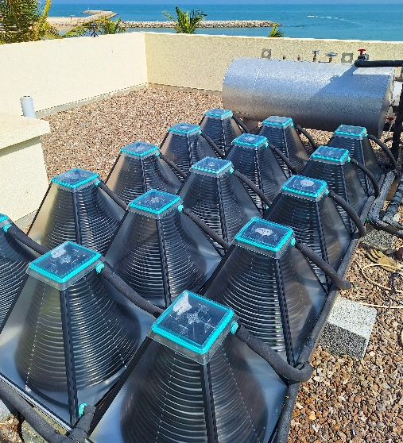
Installation of a New Design Solar Heating Solution at Rixos Al Mairid Hotel UAE
SolarisKit’s HelioFlow deployment at the Rixos Al Mairid Hotel in Ras Al Khaimah, United Arab Emirates, demonstrates a solar thermal domestic hot water system engineered specifically for hot-arid Gulf conditions. The system was designed to address common regional barriers such as overheating, hard-water scaling, and storm resilience. Monitored comparison data from the site showed major reductions in backup electricity use, and the successful deployment led to a full-property rollout order, highlighting the technology’s commercial promise for hospitality and residential applications across the GCC and beyond.
Figure 1 SolarisKit HelioFlow: Photo Credit: Faisal Ghani
For more information on SolarisKit please contact
Faisal Ghani: f.ghani@solariskit.com
Visit: https://solariskit.com

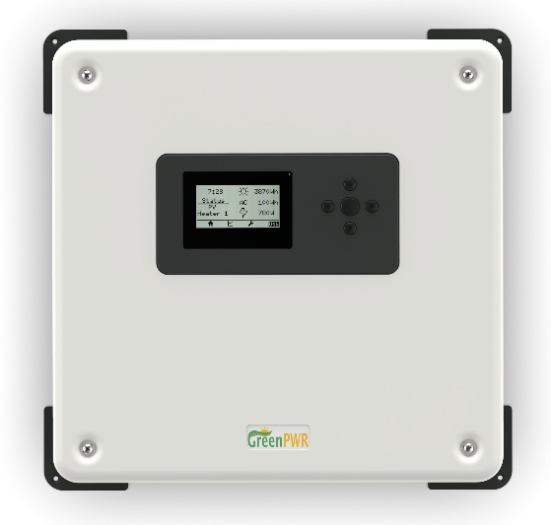
SunHopper-D
SunHopper-D is a photovoltaic-to-hot-water retrofit solution that powers standard immersion heaters from a dedicated PV array. Designed as a non-exporting system, it avoids many of the interconnection challenges associated with grid-connected solar while helping households increase their solar fraction for domestic hot water. Smart controls and an integrated app use weather forecasts and learned hot water usage patterns to optimise solar input, reduce grid reliance, and improve household energy resilience. The solid-state, grid-independent SunHopper-D inverter utilises predictive algorithms to maximise solar self-consumption for residential thermal energy storage. The SunHopper algorithm ensures a reliable hot water supply while driving down energy costs.
Figure 2 SunHopper: The solid-state, grid-independent SunHopper-D: Photo Credit: GreenPWR, Inc.
For more information on SunHopper – D. please contact
SunHopper: info@greenpwr.com
Visit: www.greenpwr.com

Solar District Heating in Rauschenberg-Bracht and Amöneburg-Rüdigheim
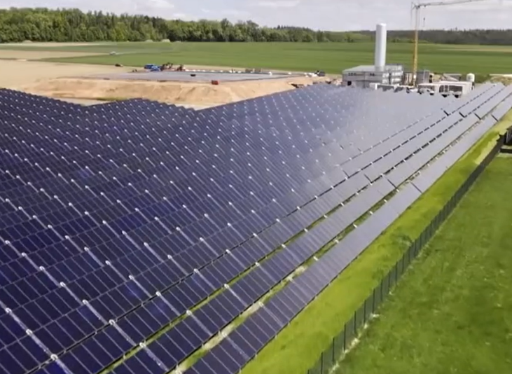
These first of their kind village-scale solar district heating initiatives in Hesse, Germany, combines heat supplied predominantly by solar thermal collectors to existing rural communities. Combined with seasonal thermal storage, and heat pumps to provide low-carbon heat in a moderate climate. Implemented through citizen energy cooperatives, these projects demonstrate how centralised solar heating can support rapid, community-wide decarbonisation while strengthening local ownership and engagement. The projects are also creating strong interest from other municipalities seeking practical pathways to reduce dependence on fossil fuels and biomass for heat.
Figure 3 Aerial view of the system, including the heating central, PTES, and collector field: Photo Credit: Hessischer Rundfunk
For more information on the Rauschenberg-Bracht systems please contact
Klaus Vajen: vajen@uni-kassel.de & Volk, Paul: paul.volk@uni-kassel.de
Visit: www.uni-kassel.de/go/ruralheat_en

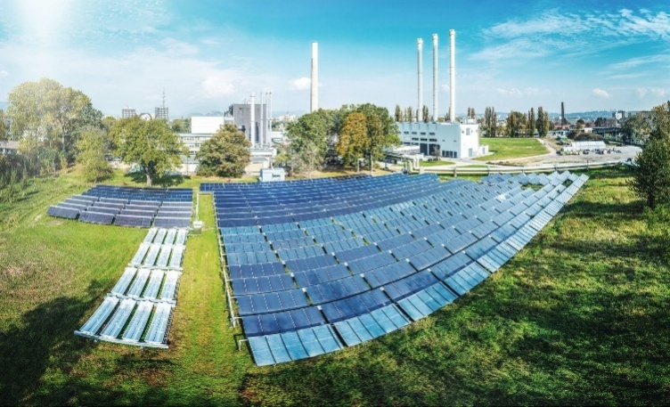
SunPeek Open-Source Project
SunPeek is an open-source software platform for automated performance verification and monitoring of large-scale solar thermal plants. Developed to support solar district heating and industrial process heat systems, SunPeek provides an ISO 24194-aligned tool for standardised reporting, early fault detection, and long-term performance evaluation. By helping plant owners, operators, funders, and technology providers to verify actual system performance, SunPeek strengthens confidence in large-scale solar thermal investments and supports improved bankability, operation, and market growth.
Figure 4Fernheizwerk Graz, collector test field with 3 different solar thermal technologies from 7 different manufacturers: Photo Credit: SOLID Energy Systems GmbH
For more information on SunPeek please contact
Philip Ohnewein: philip.ohnewein@gmail.com
Maria Moser: m.moser@solid.at
Visit: https://sunpeek.org/ or https://gitlab.com/sunpeek/sunpeek/
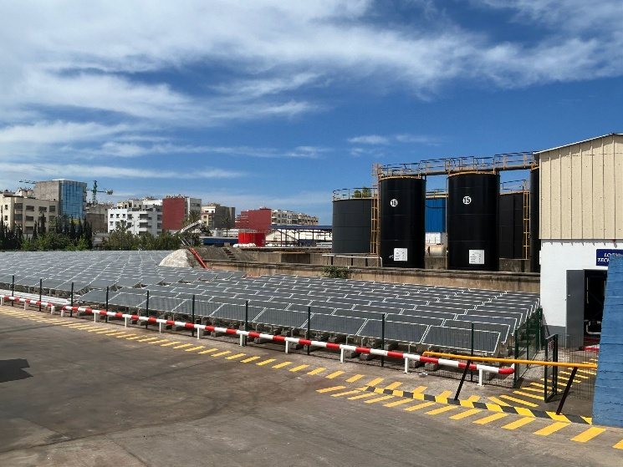
Solar Low-Pressure Steam Plant at Shell & Vivo Lubricants in Casablanca, Morocco
Figure 5 1,750 m2 high-vacuum flat plate solar field: Photo Credit: TVP Solar
TVP SOLAR’s industrial solar thermal plant in Casablanca, Morocco, uses high-vacuum flat-panel collectors and a steam generation unit to produce low-pressure process steam for Shell & Vivo Lubricants. The project demonstrates a replicable approach for decarbonising industrial steam loads in sun-rich markets, particularly where propane and LPG remain dominant fuels for process heat. By producing industrial-quality steam with stationary, non-concentrating collectors, the project offers a promising model for reducing fossil fuel use in downstream oil and gas operations and other industrial sectors.
For more information on TVP’s low pressure steam plant please contact
Florent Saunier: saunier@tvpsolar.com
Visit: Home - TVP Solar

About the SHC Solar Award
The SHC Solar Award celebrates the success of individuals, companies, public institutions, and organisations working to increase the market impact of solar heating and cooling technologies. Awarded by the IEA Solar Heating and Cooling Technology Collaboration Programme, the award recognises outstanding leadership and achievements that support the deployment of solar heating and cooling solutions worldwide.
About IEA SHC
The IEA Solar Heating and Cooling Technology Collaboration Programme works to increase the deployment of solar heating and cooling technologies through international collaboration, research, knowledge sharing, and market support. IEA SHC brings together experts from around the world to advance solar thermal technologies and support their role in sustainable energy systems.
www.iea-shc.org
Media Contact
IEA Solar Heating and Cooling Technology Collaboration Programme
Ben Stinson
Secretariat
secretariat@iea-shc.org

